

***2019 - 2020***

SUBMITTED TO SUBMITTED BY

Mr VIVEK PANDAY NISHANT GUPTA

PGT(C.S) XII

ACKNOWLEDGEMENT

*I would like to express my special thanks of gratitude to my teacher Mr* ***VIVEK PANDAY*** *as well as our principal Mr* ***R C DHASMANA*** *who gave me the golden opportunity to do this wonderful project on the topic* ***TRAVELLLING MANAGEMENT SYSTEM****, which also helped me in doing a lot of Research and i came to know about so many new things I am really thankful to them.*  
*Secondly i would also like to thank my parents and friends who helped me a lot in finalizing this project within the limited time frame.*

Certificate

This is to certify that **NISHANT GUPTA** student of class **XII/B** has undertaken a project on **TRAVELLING MANAGEMENT SYSTEM** under my supervision and guidance.

This project is in partial fulfillment for award of senior secondary exam.

To the best of my knowledge this work is so far has not been carried on submitted by else.

His hard work and enthusiasm during the project was found quite appreciable.

Mr. Vivek Pandey Mr. R.C. Dhasmana

PGT (C S) (Principal)

CONTENTS

#### Problem Statement

#### About C++

* + **History and Features of C++**
* **Hardware & Software Requirements**
* **Forms Layout**
* **Coding**
* **Bibliography**

**History of C++**

C++ Programming language was developed by AT & T Bell laboratories in the early 1980s by Bjarne Stroustrup. C++ Orignally known as C with classes. Two languages contributed to its design - **C** (Which provide low level Features) and **Simula 67** which provide the concept of class. **C++ is an Object Oriented Programming language.**

**Basic Concepts of Object Oriented Programming:**

The object oriented programming has been develop with a view to overcome the drawback of conventional programming approaches. The OPP approach is based on certain concepts that help it to overcome the drawbacks or short comings of conventional programming approaches.

The general concepts of OOP are given below.

* 1. Data Abstraction
  2. Data Encapsulation
  3. Object
  4. Class
  5. Inheritance
  6. Polymorphism
  7. Data Hiding
  8. Modularity

**1) Data Abstraction:** Abstraction is the act of representing essential features without knowing the background details or explanations.

To understand abstraction, let us take an example we are driving a car we only know the essential feature to drive a car i.e. gear handling, steering handle, use of clutch, accelerator, brakes etc. But while we driving the car what is happening inside the body of car is hidden from us. This is abstraction where we only know the essential things to drive a car without including the background details or explanation.

**2) Data Encapsulation:** The Wrapping up of data and function into a single unit is called data encapsulation.

**3) Object:** Object is an identifiable entity that has some characteristics and behavior. While Programming using object oriented approach the characteristics of an object are represented by its data and its behavior is represented by its function associated. Therefore, in object oriented programming object represents data and its associated functions under a single unit.

**4) Class**: A Class is a group of Objects that share common properties and relationship.

**5) Inheritance:** Inheritance is the process by which object of one class acquire the property of another class. It supports the concept of hierarchical classification.

The Class CAR and BUS Inherits some of its properties from class ‘AUTOMOBILES’ which inherits some of its properties from class Vehicle. Similarly class CART and RICKSHAW inherits some of its properties from class ‘PULLED VEHICLE’ which inherits some of its properties from class Vehicle.

**Here AUTOMOBILE** and **PULLED VEHICLE** are sub class or derived class of class **VEHICLE** & **VEHICLE** is the base class of class **AUTOMOBILE** and **PULLED VEHICLE**.

**Here** **CAR** and **BUS** are sub class or Derived class of class **AUTOMOBILE** and AUTOMOBILE is the base class of class **CAR** and **BUS.**

**6. Polymorphism**:

The Word Polymorphism is made up from two words Poly and morphism. Poly means many and morphism means ability, Therefore polymorphism is ability for a data or message to be processed in more than one form. Polymorphism is a property by which same message can be sent to objects of several different classes and each object can respond in a different way depending on its class.

**Shape**

**Area ()**

**Triangle**

**Area (Triangle)**

**Rectangle**

**Area (Rectangle)**

**Circle**

**Area (Circle)**

**(Polymorphism)**

**7) Data Hiding:** In the context of Object oriented Programming, data hiding is a property whereby the internal data structure of an object is hidden from the rest of the program.

Example:

class student

{

int rollno;

char name[30]; // These members will remain hidden from outside world

int age;

char grade;

char calgrade();

public:

void getdata();

void showdata();

};

**8)** **Modularity:** The act of partitioning a program into individual components is called Modularity. The justification for portioning a program is that

**a) Its reduces its complexity to some degree.**

**b) It Create a no. of well defined documented boundaries with in a program.**

A module is a separate unit itself. It can be compiled separately though it has connections with other modules. Module work hand in hand to achieve the programs goal.

Problem statement

In this world, people, make programs and software to make their work easier. As like other I also made a program to make travelling booking easier. My project name is Travelling Manage

ment System. This program is very easy to operate. In this program, we can book buses, trains, flights and hotels. It will also ask you to pay the amount by your card. In this program first menu is shown. The new have to select what we want to do. The program firstly inputs the data of the person and assign a particular account number to the person, this data is stored in a file. If you want to book a travel means or hotel, you need to input membership number then you can book. All the data of the person is stored in a single file, if you want to see your bookings, you can see by this program it also allow you to modify your account. If any person wants to see the details of the person then he will input his membership number, then all the data stored in the file will be displayed.

THIS PROGRAM CAN:

1. ADD AN ACCOUNT
2. BOOK and CANCEL TRAVEL MEAN AND HOTEL
3. MODIFY YOUR ACCOUNT
4. CHECK DETAILS OF ANY ACCOUNT

MINIMUM HARDWARE REQUIREMENT

* Processor: Pentium ii 266 MHz
* RAM: 64 MB
* SVGA Color Monitor
* Keyboard & Mouse
* Hard Disk Space 100 MB

MINIMUM software REQUIREMENT

* Turbo C++
* Microsoft Office 2007

**FORMS LAYOUT**

FIRST PAGE

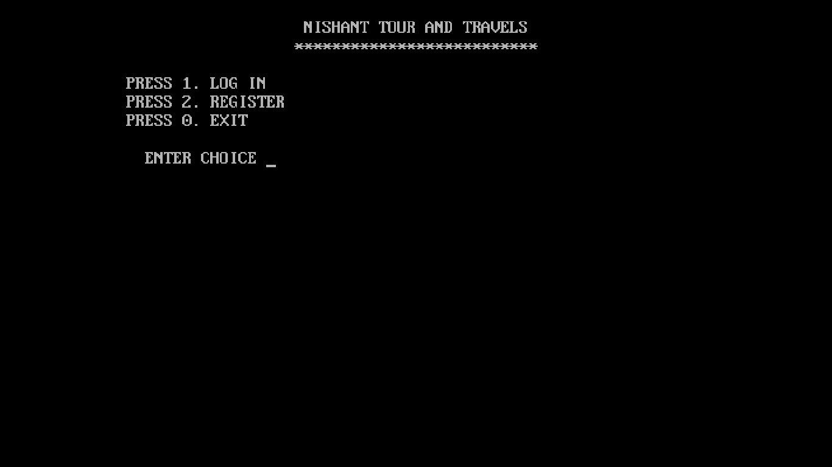

LOG IN PAGE

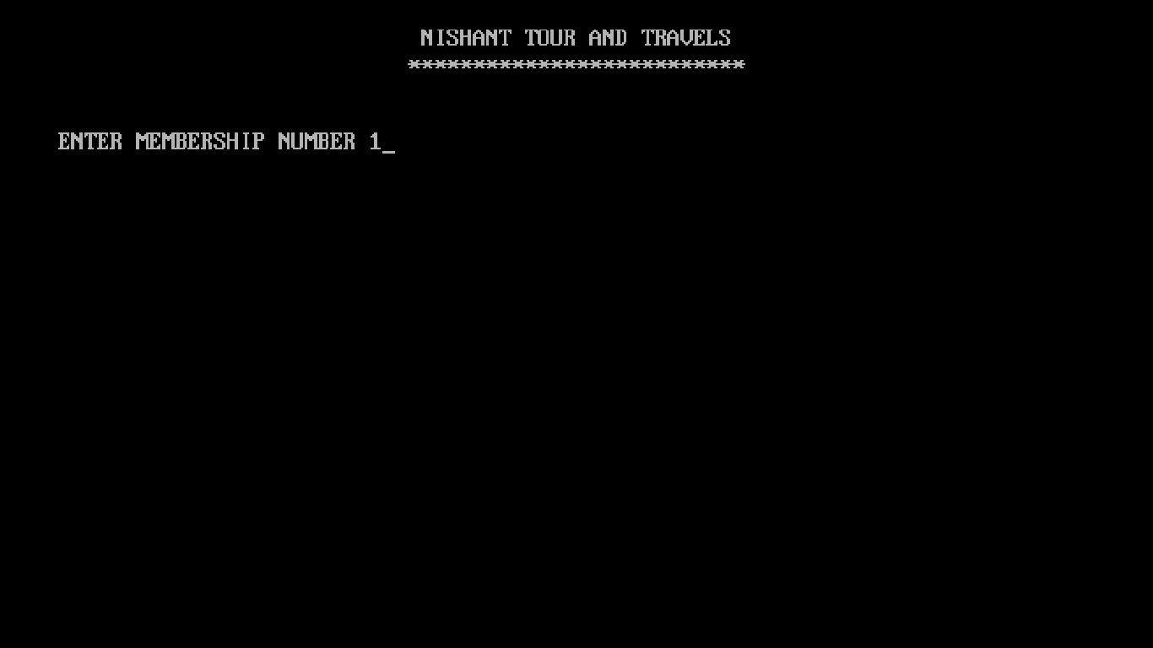

REGISTER PAGE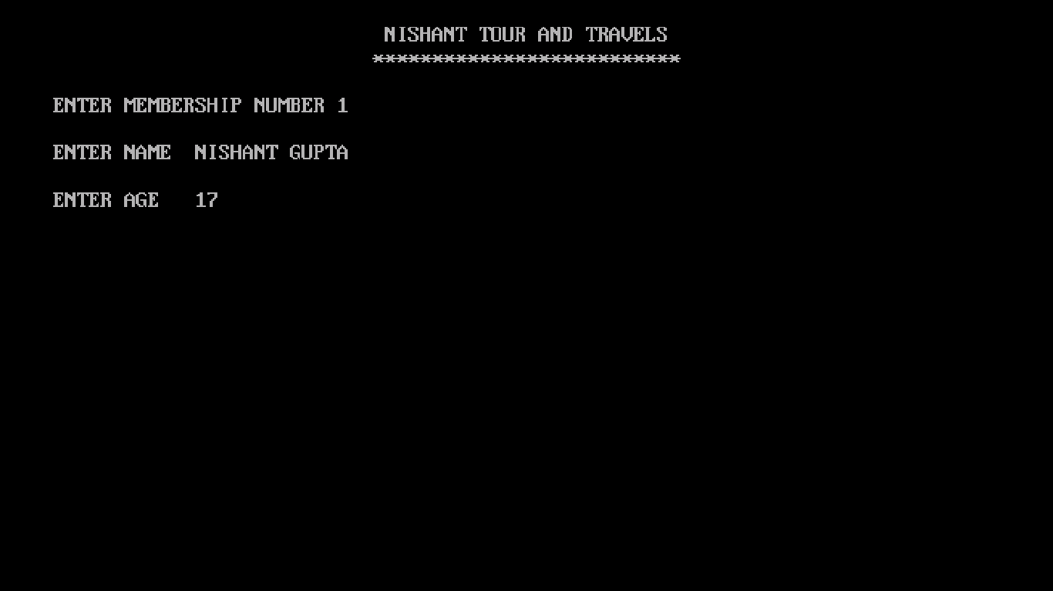

THANKS PAGE

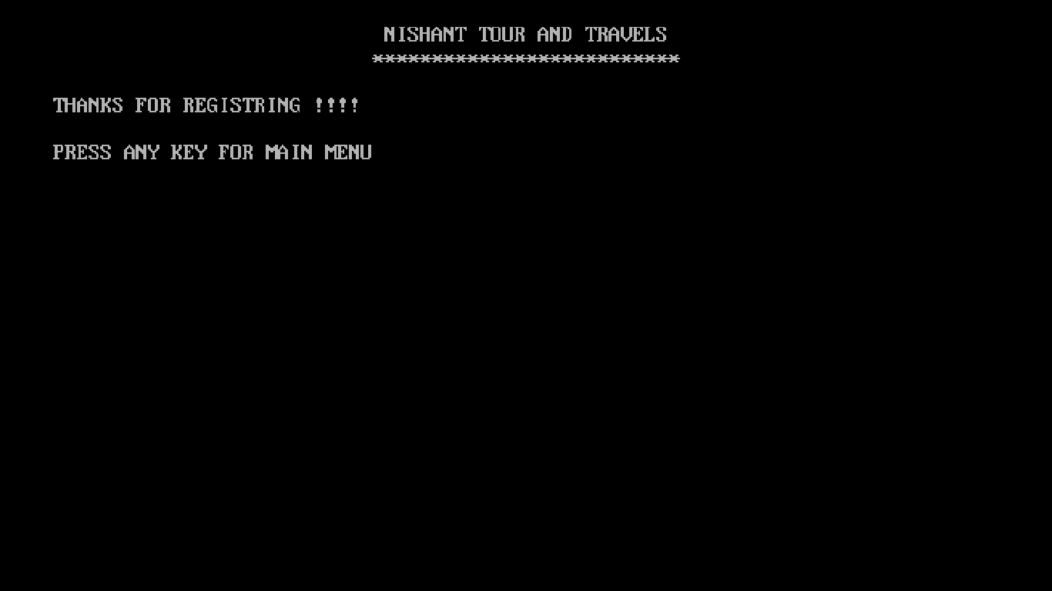

MAIN MENU

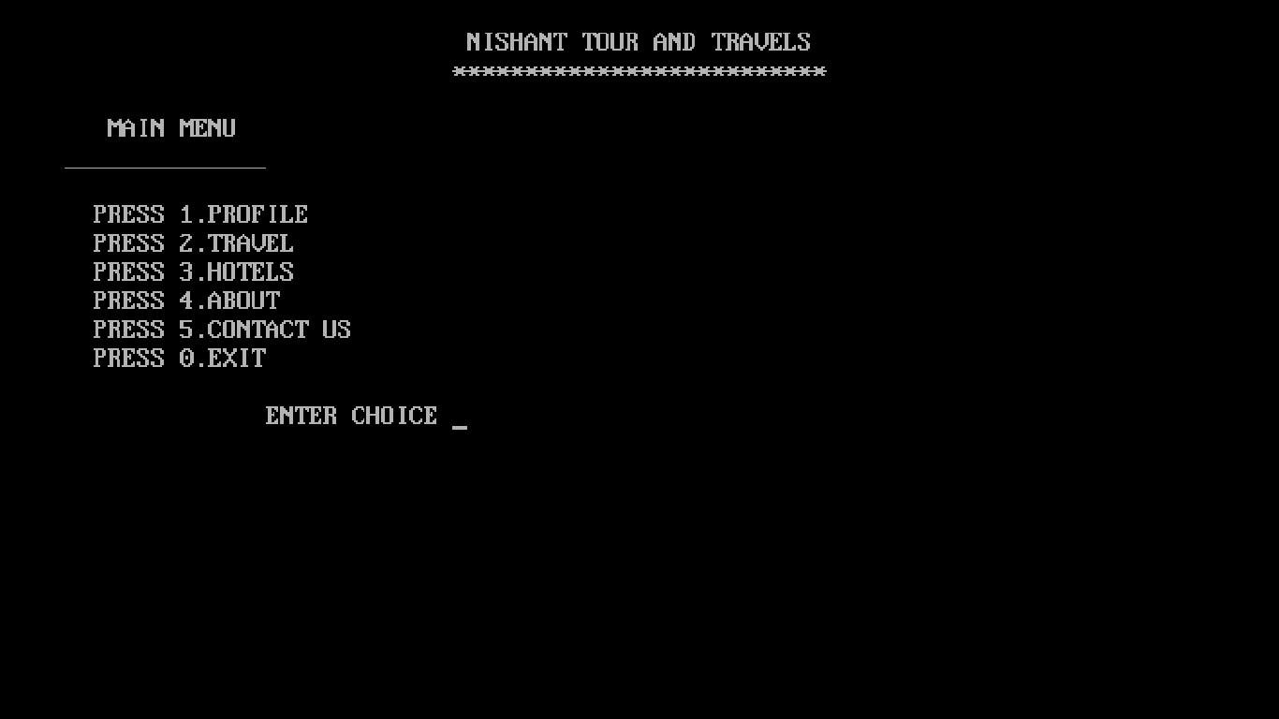

PROFILE

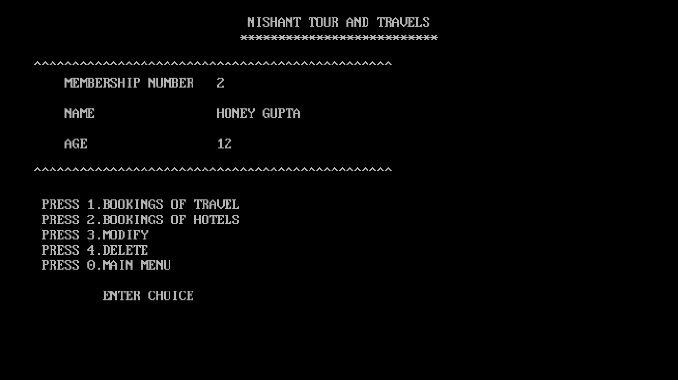

BOOKINGS OF TRAVEL

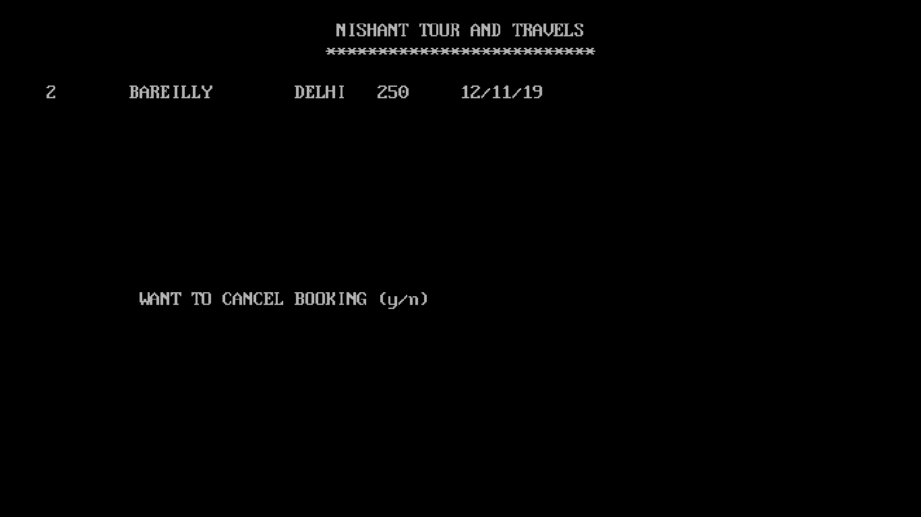

BOOKINGS OF HOTEL

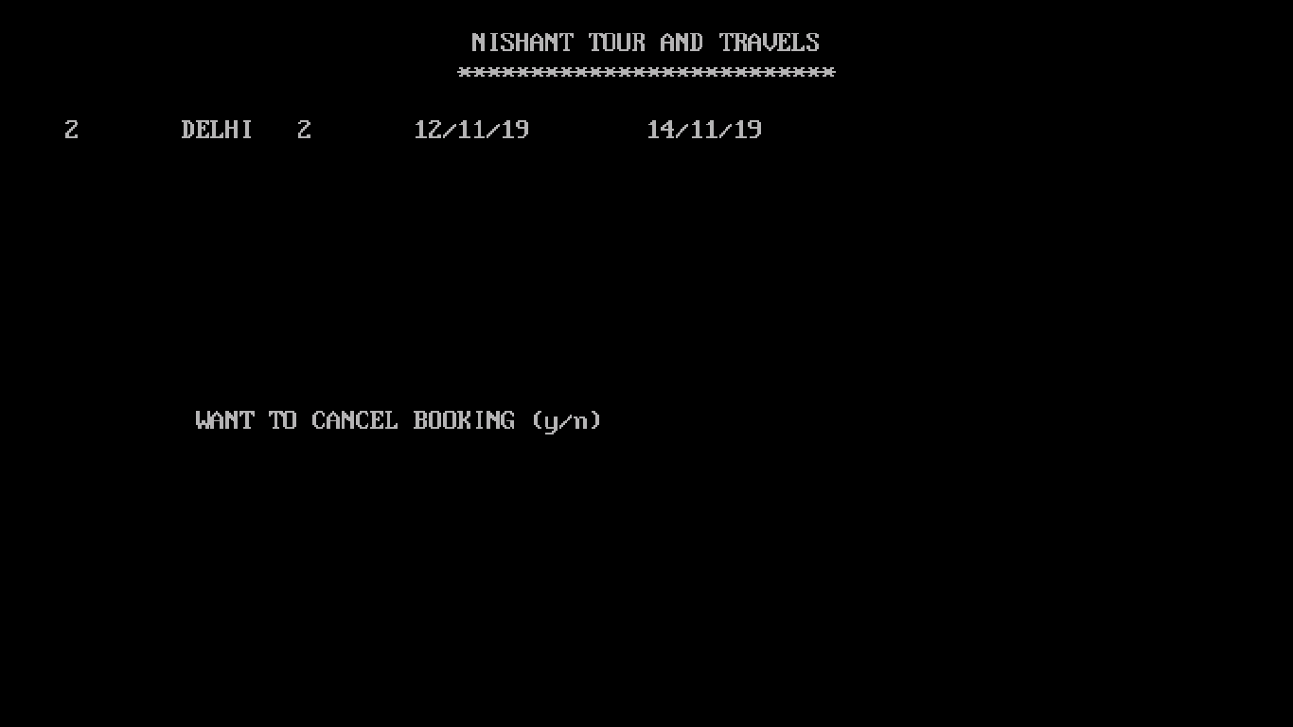

MEMBER MODIFY

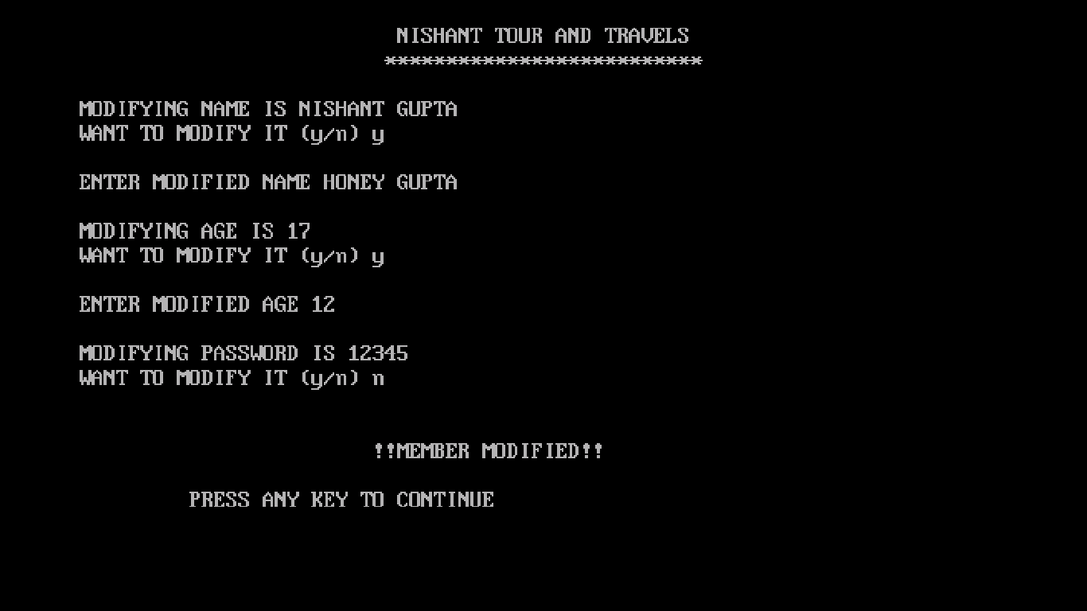

MEMBER DELETE

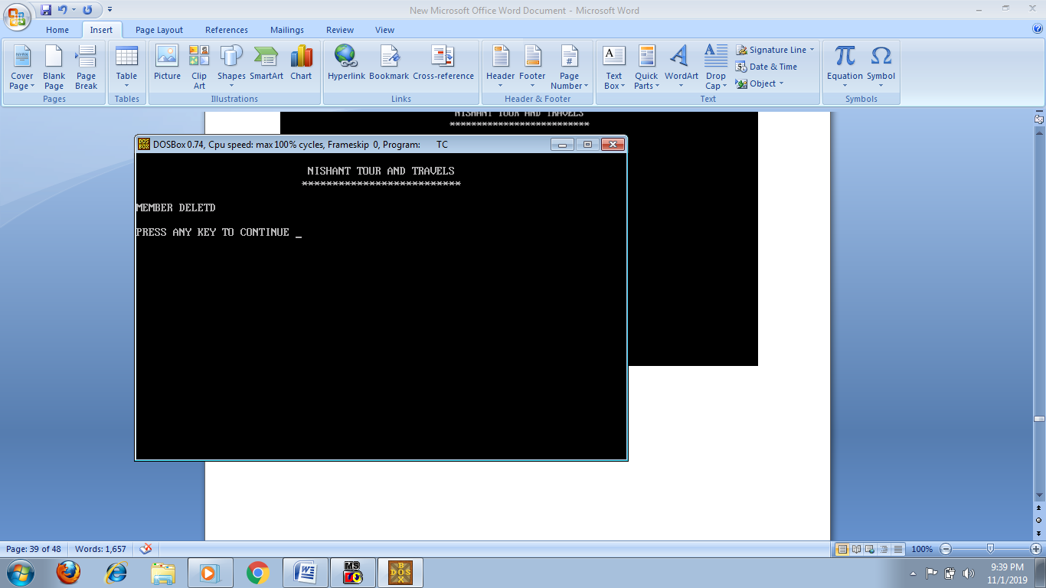

TRAVEL

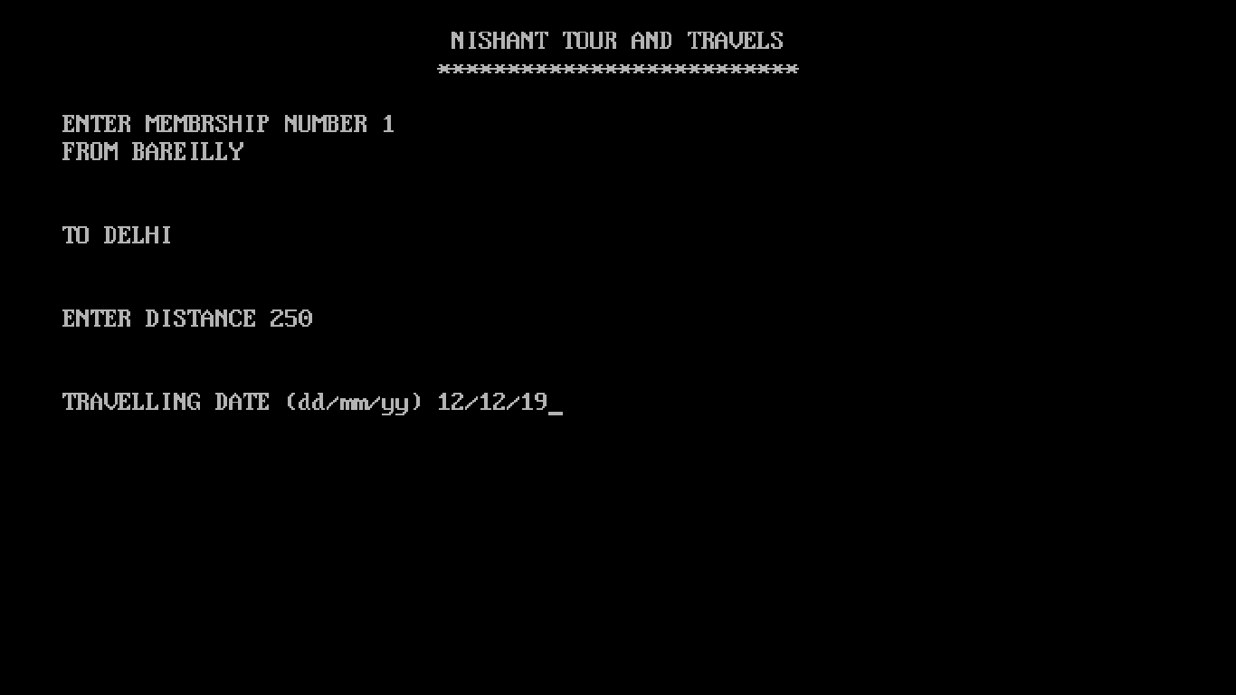MODES OF TRANSPORT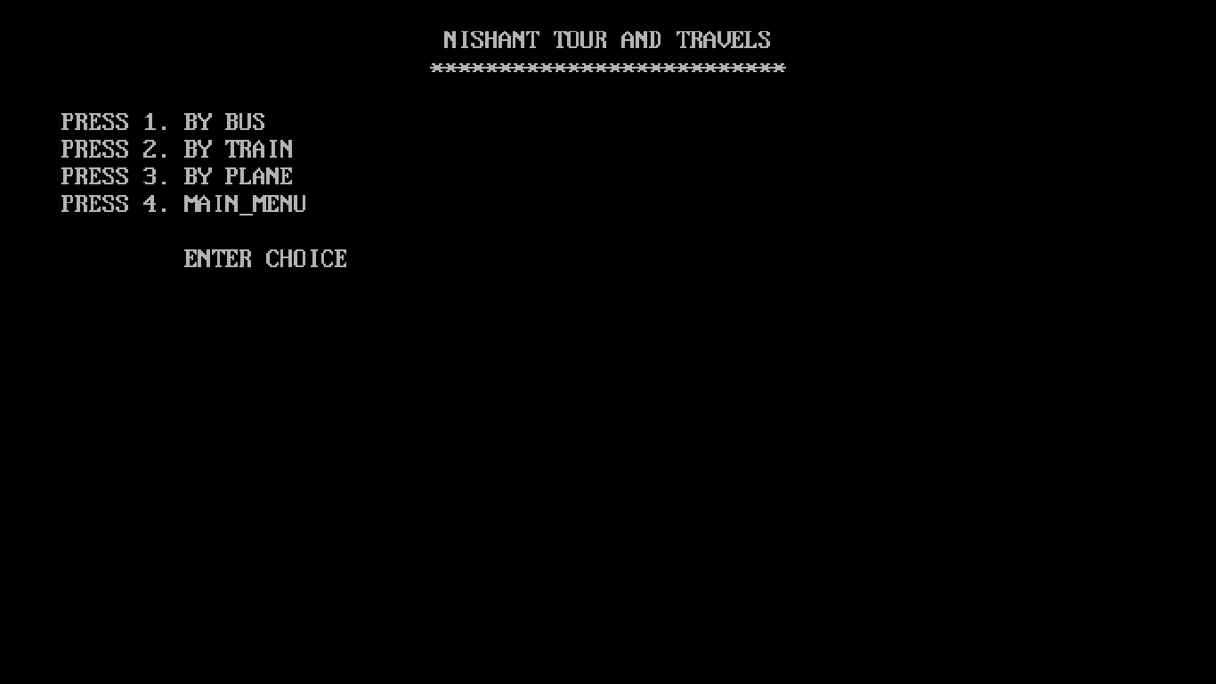

BUSES

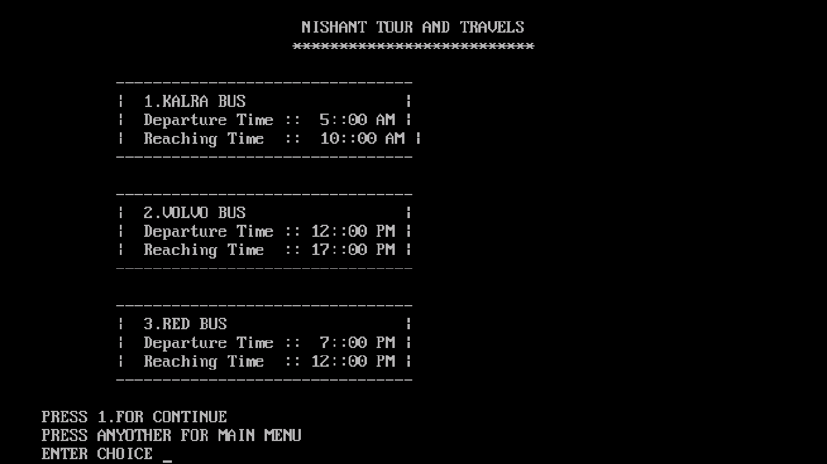

TRAINS

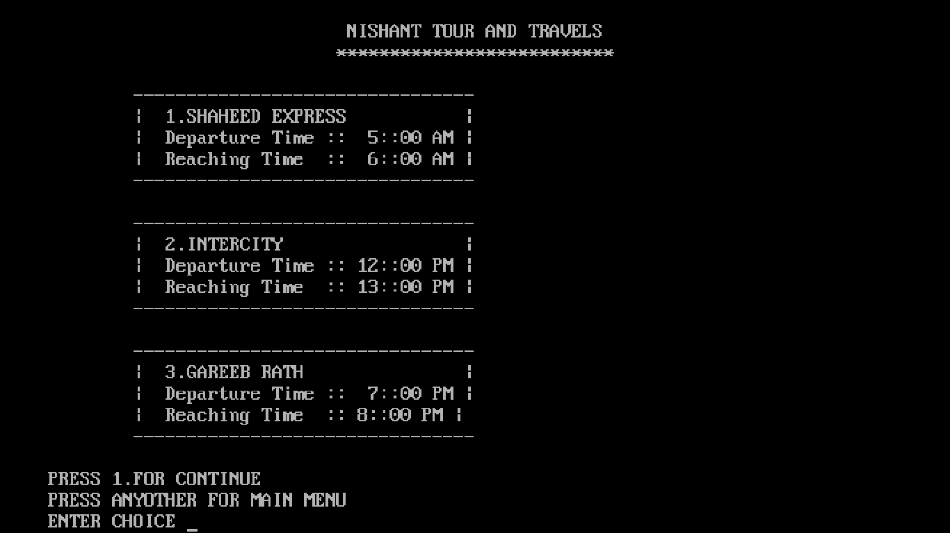

FLIGHTS

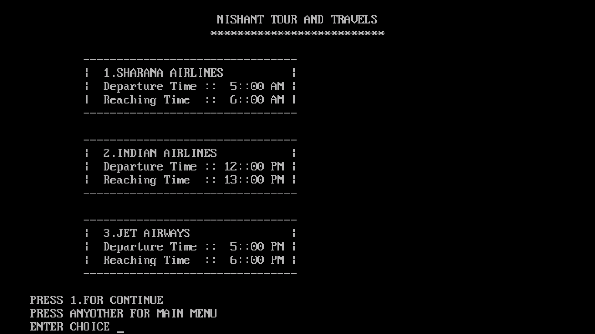

NAME OF TRANSPORT

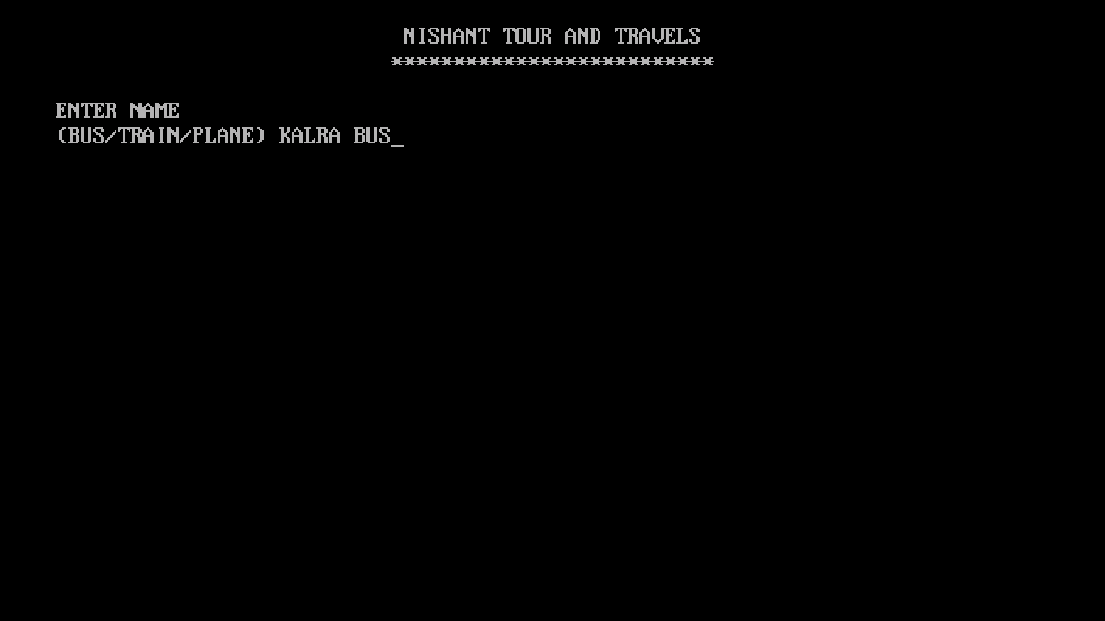

TRAVELLING BILL

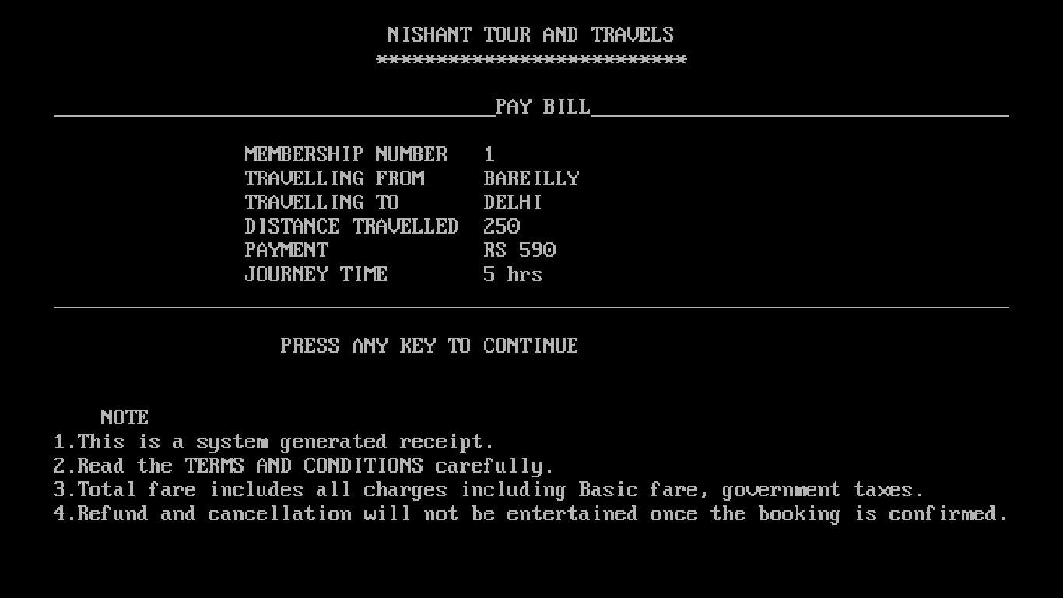

HOTEL

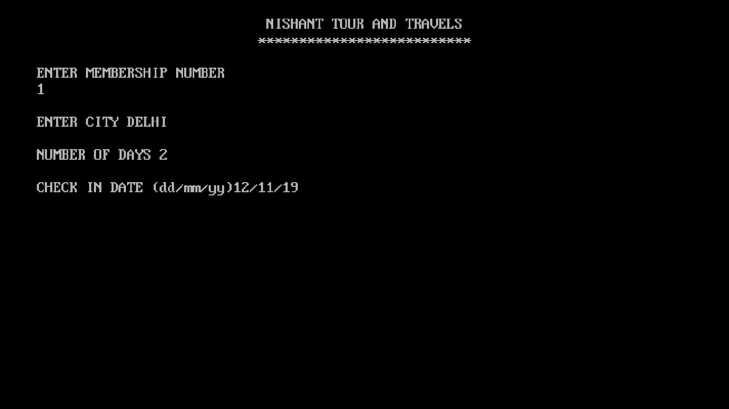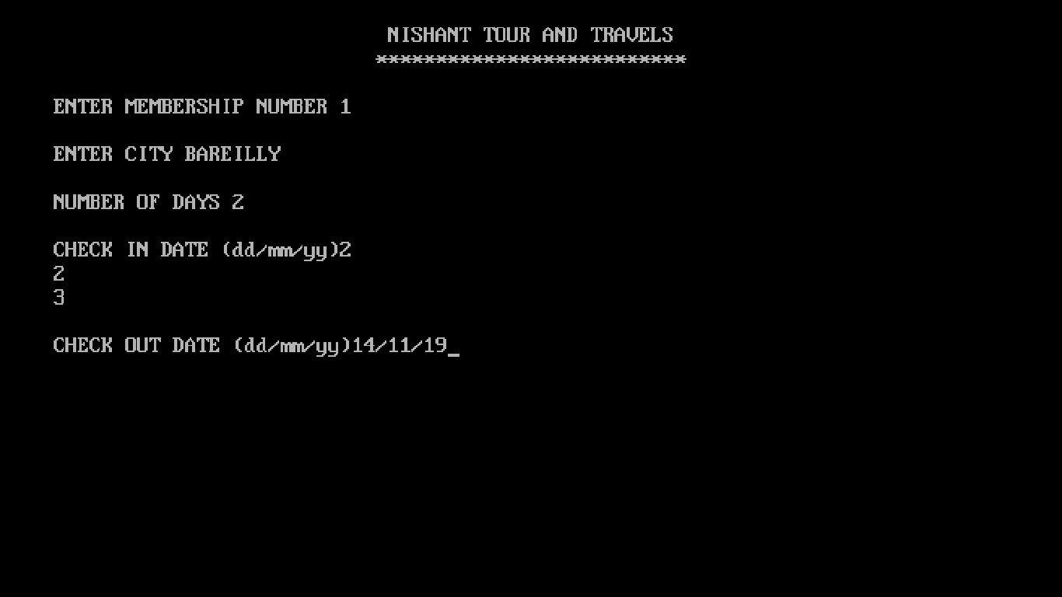

TYPES OF HOTEL

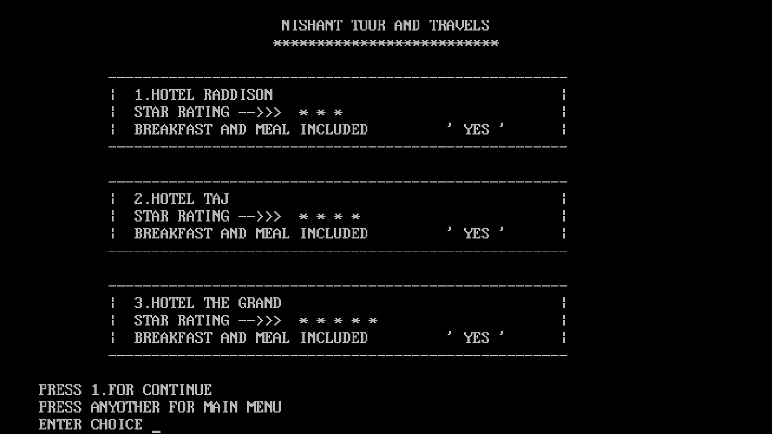

NAME OF HOTEL

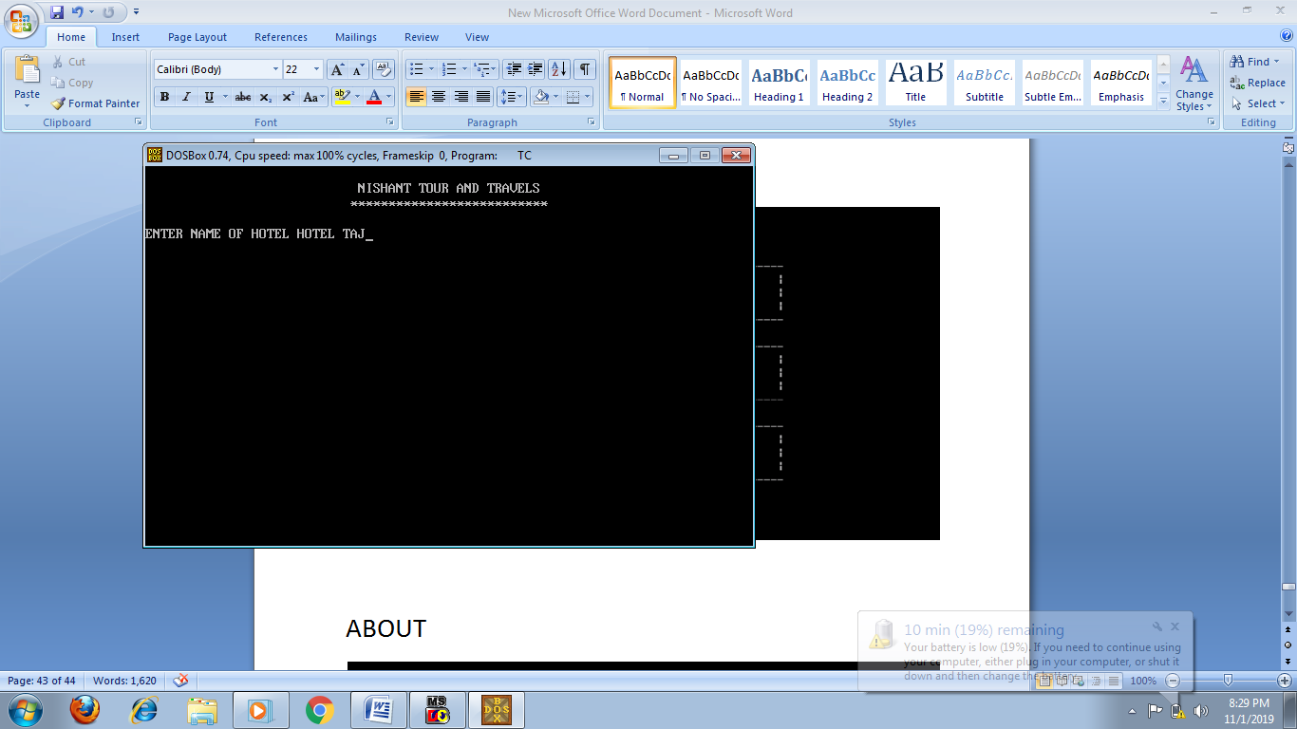HOTEL BILL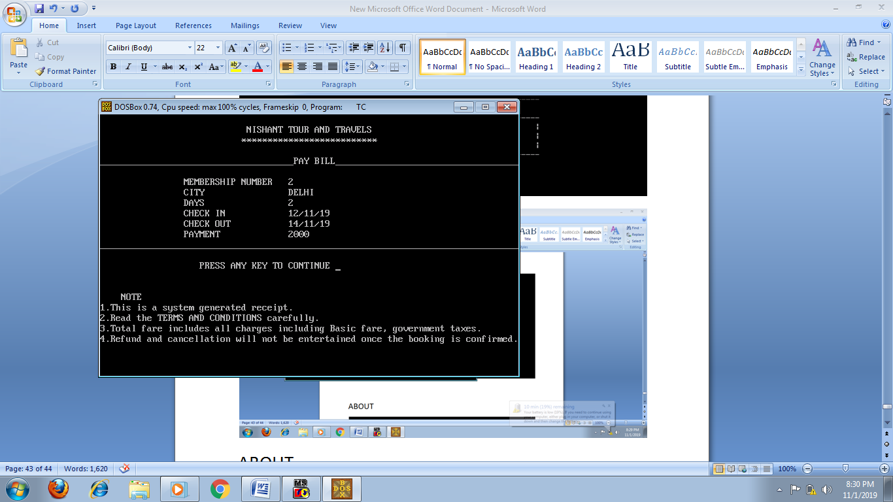

PAY BILL

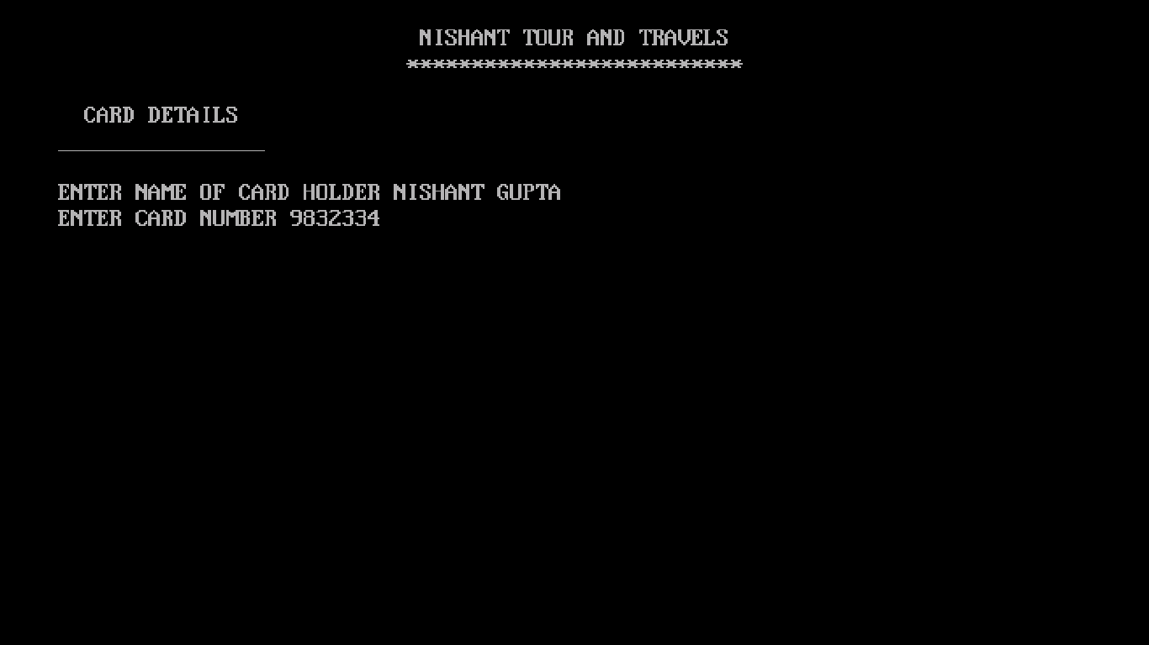

THANKS FOR BOOKING

ABOUT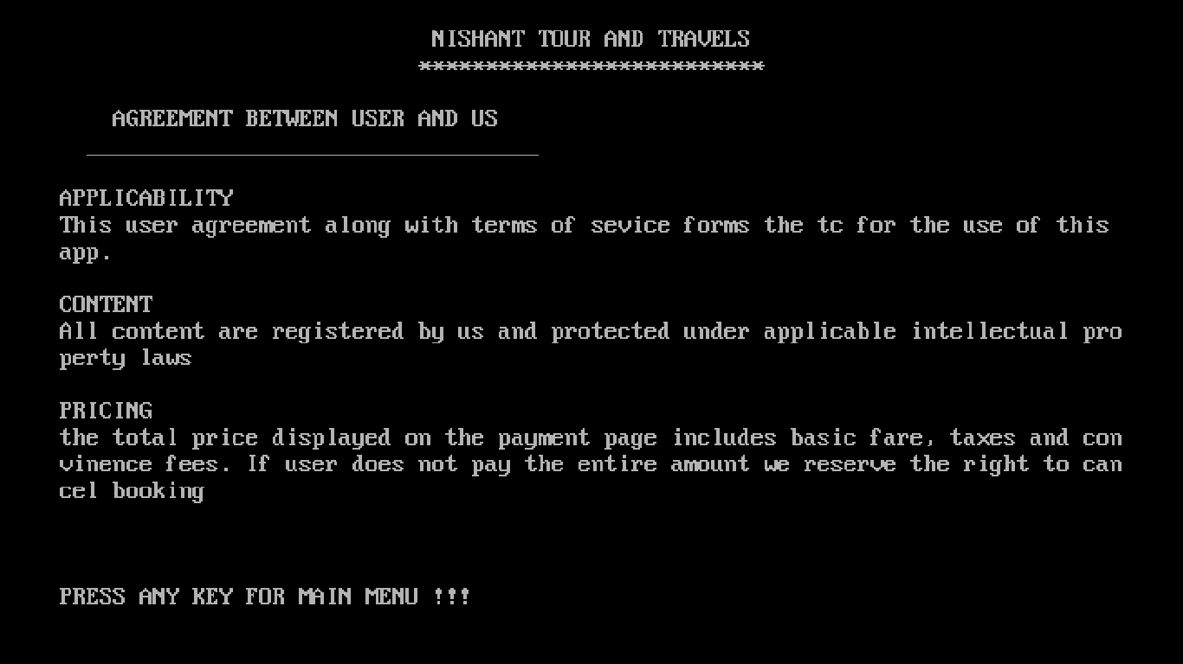

CONTACT US

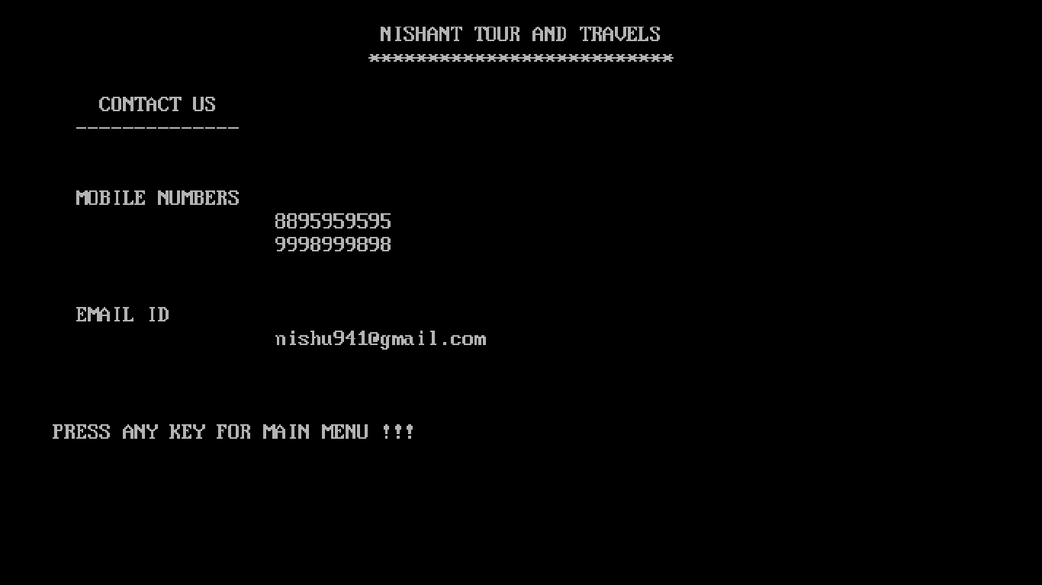

***CODING***

// HEADER FILES

#include<fstream.h>

#include<conio.h>

#include<stdio.h>

#include<dos.h>

// MEMBER FUNCTIONS DECLARATION

void welcome();

void member();

void log_in();

void header();

void hotel();

void about();

void contact();

void ne(int h);

void travel_del(int j);

void hotel_del(int a);

void safe();

void dis(int a);

void payment();

// MAIN PART

void main()

{

clrscr();

int i,ch;

clrscr();

for(i=12;i>1;i--)

{

delay(500);

clrscr();

gotoxy(23,i);

cout<<"WELCOME TO NISHANT TOUR AND TRAVELS ";

}

while(ch!='0')

{

header();

gotoxy(10,5);

cout<<"PRESS 1. LOG IN";

gotoxy(10,6);

cout<<"PRESS 2. REGISTER";

gotoxy(10,7);

cout<<"PRESS 0. EXIT";

gotoxy(12,9);

cout<<"ENTER CHOICE ";

ch=getch();

switch(ch)

{

case'1':

log_in();

break;

case'2':

member();

break;

case'0':

break;

default:

cout<<endl<<"ENTER VALID CHOICE";

break;

}

}

getch();

}

// HEADER

void header()

{

clrscr();

gotoxy(28,2);

cout<<" NISHANT TOUR AND TRAVELS ";

gotoxy(28,3);

cout<<"**************************";

cout<<endl<<endl;

}

// MAIN MENU

class s

{

public:

char name[20];

int memno;

int age;

void main_menu()

{

int choice;

while(choice!='0')

{

header();

cout<<" MAIN MENU"<<endl;

cout<<"______________";

cout<<endl<<endl;

cout<<" PRESS 1.PROFILE"<<endl;

cout<<" PRESS 2.TRAVEL"<<endl;

cout<<" PRESS 3.HOTELS"<<endl;

cout<<" PRESS 4.ABOUT"<<endl;

cout<<" PRESS 5.CONTACT US"<<endl;

cout<<" PRESS 0.EXIT"<<endl;

cout<<endl<<" ENTER CHOICE ";

choice=getch();

switch(choice)

{

case'1':

y.profile();

break;

case'2':

ol();

break;

case'3':

safe();

break;

case'4':

about();

break;

case'5':

contact();

break;

case'0':

break;

default:

cout<<endl<<"ENTER VALID CHOICE";

break;

}

}

}

void input()

{

header();

cout<<"ENTER MEMBERSHIP NUMBER ";

cin>>memno;

cout<<endl<<"ENTER NAME ";

gets(name);

cout<<endl<<"ENTER AGE ";

cin>>age;

header();

cout<<"THANKS FOR REGISTRING !!!!"<<endl;

cout<<endl<<"PRESS ANY KEY FOR MAIN MENU " ;

getch();

}

int return_paas()

{

return memno;

}

}x;

void log_in()

{

int paas,z,memno1;

int c;

int f=0;

header();

cout<<endl<<"ENTER MEMBERSHIP NUMBER ";

cin>>memno1;

ifstream fin;

fin.open("mem.dat",ios::binary);

while(fin.read((char*) &x,sizeof(x)))

{

z=x.return_paas();

if(memno1==z)

{

f=1;

}

}

if(f==1)

{

f=0;

x.main_menu();

}

else if(f==0)

{

cout<<endl<<"NOT REGISTERD"<<endl;

getch();

}

fin.close();

}

void member()

{

clrscr();

s z;

int f=0;

header();

ifstream fin;

fin.open("mem.dat",ios::binary);

cout<<"ENTER MEMBERSHIP NUMBER TO CHECK ";

cin>>x.memno;

while(fin.read((char*)&z,sizeof(z)))

{

if(z.memno==x.memno)

{

f=1;

}

}

if(f==0)

{

ofstream fout;

fout.open("mem.dat",ios::binary|ios::app);

x.input();

fout.write((char*)&x,sizeof(x));

fout.close();

x.main_menu();

}

else

{

cout<<"MEMBER EXISTS ";

getch();

}

fin.close();

}

// PROFILE

class pro_ile

{

public:

void profile()

{

int choice,memno1,f=0;

header();

cout<<"ENTER MEMBERSHIP NUMBER ";

cin>>memno1;

ifstream fin;

fin.open("mem.dat",ios::binary);

while(fin.read ((char *) &x, sizeof(x)))

{

if(memno1==x.memno)

{

f=1;

header();

cout<<"^^^^^^^^^^^^^^^^^^^^^^^^^^^^^^^^^^^^^^^^^^^^^^^"<<endl;

cout<<" MEMBERSHIP NUMBER "<<x.memno<<endl<<endl;

cout<<" NAME "<<x.name<<endl<<endl;

cout<<" AGE "<<x.age<<endl<<endl;

cout<<"^^^^^^^^^^^^^^^^^^^^^^^^^^^^^^^^^^^^^^^^^^^^^^^"<<endl<<endl;

cout<<" PRESS 1.BOOKINGS OF TRAVEL "<<endl;

cout<<" PRESS 2.BOOKINGS OF HOTELS "<<endl;

cout<<" PRESS 3.MODIFY "<<endl;

cout<<" PRESS 4.DELETE "<<endl;

cout<<" PRESS 0.MAIN MENU "<<endl;

cout<<endl<<" ENTER CHOICE ";

choice=getch();

switch(choice)

{

case'1':

ne(memno1);

break;

case'2':

dis(memno1);

break;

case'3':

modify(x.memno);

break;

case'4':

del(x.memno);

break;

case'0':

x.main_menu();

break;

case'9':

break;

default:

cout<<endl<<"ENTER VALID CHOICE";

break;

}

break;

}

}

if(f==0)

{

cout<<"NO THANKS";

getch();

}

fin.close();

getch();

}

void del(int a)

{

int f=0;

ifstream fin;

fin.open("mem.dat",ios::binary);

ofstream fout;

fout.open("temp.dat",ios::binary);

while(fin.read((char *)&x,sizeof(x)))

{

if(a==x.memno)

{

f=1;

}

else

{

fout.write((char *)&x, sizeof(x));

}

}

fout.close();

fin.close();

remove("mem.dat");

rename("TEMP.dat","MEM.dat");

if(f==1)

{

header();

cout<<"MEMBER DELETD"<<endl<<endl;

cout<<"PRESS ANY KEY TO CONTINUE ";

getch();

}

}

void modify(int a)

{

int f=0;

char ch,ch1,ch2;

ifstream fin;

fin.open("mem.dat",ios::binary);

ofstream fout;

fout.open("temp.dat",ios::binary,ios::app);

while(fin.read((char *)&x,sizeof(x)))

{

if(a==x.memno)

{

clrscr();

header();

f=1;

fin.open("mem.dat",ios::binary,ios::in|ios::out|ios::app);

cout<<" MODIFYING NAME IS "<<x.name<<endl;

cout<<" WANT TO MODIFY IT (y/n) ";

cin>>ch;

if(ch=='y'||ch=='Y')

{

cout<<endl<<" ENTER MODIFIED NAME ";

gets(x.name);

}

cout<<endl<<" MODIFYING AGE IS "<<x.age<<endl;

cout<<" WANT TO MODIFY IT (y/n) ";

cin>>ch1;

if(ch1=='y'||ch=='Y')

{

cout<<endl<<" ENTER MODIFIED AGE " ;

cin>>x.age;

}

fout.write((char*)&x,sizeof(x));

}

else

{

fout.write((char *)&x, sizeof(x));

}

}

fout.close();

fin.close();

remove("mem.dat");

rename("TEMP.dat","MEM.dat");

if(f==1)

{

cout<<endl<<endl<<" !!MEMBER MODIFIED!!"<<endl<<endl;

cout<<" PRESS ANY KEY TO CONTINUE ";

getch();

}

}

}y;

// TRAVEL

class tra_vel

{

public:

int memno;

char from[30],to[30];

int distance;

int dd;

int mm;

int yy;

void travel()

{

int choice;

header();

cout<<"ENTER MEMBRSHIP NUMBER ";

cin>>memno;

cout<<"FROM ";

gets(from);

cout<<endl<<endl;

cout<<"TO ";

gets(to);

cout<<endl<<endl;

cout<<"ENTER DISTANCE ";

cin>>distance;

cout<<endl<<endl;

cout<<"TRAVELLING DATE (dd/mm/yy) ";

cin>>dd>>mm>>yy;

header();

cout<<"PRESS 1. BY BUS "<<endl;

cout<<"PRESS 2. BY TRAIN "<<endl;

cout<<"PRESS 3. BY PLANE "<<endl;

cout<<"PRESS 4. MAIN_MENU "<<endl;

}

void bus(int distance)

{

float rate;

int choice,time;

time=distance/60+1;

rate=distance*2;

rate+=18*rate/100;

header();

cout<<"\t"<<"--------------------------------"<<endl;

cout<<"\t"<<"| 1.KALRA BUS |"<<endl;

cout<<"\t"<<"| Departure Time :: 5::00 AM |"<<endl;

cout<<"\t"<<"| Reaching Time :: "<<5+time<<"::00 AM |"<<endl;

cout<<"\t"<<"--------------------------------"<<endl;

cout<<endl;

cout<<"\t"<<"--------------------------------"<<endl;

cout<<"\t"<<"| 2.VOLVO BUS |"<<endl;

cout<<"\t"<<"| Departure Time :: 12::00 PM |"<<endl;

cout<<"\t"<<"| Reaching Time :: "<<12+time<<"::00 PM |"<<endl;

cout<<"\t"<<"--------------------------------"<<endl;

cout<<endl;

cout<<"\t"<<"--------------------------------"<<endl;

cout<<"\t"<<"| 3.RED BUS |"<<endl;

cout<<"\t"<<"| Departure Time :: 7::00 PM |"<<endl;

cout<<"\t"<<"| Reaching Time :: "<<7+time<<"::00 PM |"<<endl;

cout<<"\t"<<"--------------------------------"<<endl;

cout<<endl<<"PRESS 1.FOR CONTINUE "<<endl;

cout<<"PRESS ANYOTHER FOR MAIN MENU "<<endl;

cout<<"ENTER CHOICE ";

choice=getch();

switch(choice)

{

case'1':

pay_bill(rate,time);

break;

default:

x.main_menu();

break;

}

}

void train(int distance)

{

float rate;

int choice,time;

time=distance/70+1;

rate=distance*1.5;

rate+=18*rate/100;

header();

cout<<"\t"<<"--------------------------------"<<endl;

cout<<"\t"<<"| 1.SHAHEED EXPRESS |"<<endl;

cout<<"\t"<<"| Departure Time :: 5::00 AM |"<<endl;

cout<<"\t"<<"| Reaching Time :: "<<5+time<<"::00 AM |"<<endl;

cout<<"\t"<<"--------------------------------"<<endl;

cout<<endl;

cout<<"\t"<<"--------------------------------"<<endl;

cout<<"\t"<<"| 2.INTERCITY |"<<endl;

cout<<"\t"<<"| Departure Time :: 12::00 PM |"<<endl;

cout<<"\t"<<"| Reaching Time :: "<<12+time<<"::00 PM |"<<endl;

cout<<"\t"<<"--------------------------------"<<endl;

cout<<endl;

cout<<"\t"<<"--------------------------------"<<endl;

cout<<"\t"<<"| 3.GAREEB RATH |"<<endl;

cout<<"\t"<<"| Departure Time :: 7::00 PM |"<<endl;

cout<<"\t"<<"| Reaching Time :: "<<7+time<<"::00 PM |"<<endl;

cout<<"\t"<<"--------------------------------"<<endl;

cout<<endl<<"PRESS 1.FOR CONTINUE "<<endl;

cout<<"PRESS ANYOTHER FOR MAIN MENU "<<endl;

cout<<"ENTER CHOICE ";

choice=getch();

switch(choice)

{

case'1':

pay_bill(rate,time);

break;

default:

x.main_menu();

break;

}

}

void plane(int distance)

{

char ch[30];

float rate;

int choice,time;

time=distance/150+1;

rate=distance*5;

rate+=18*rate/100;

header();

cout<<"\t"<<"--------------------------------"<<endl;

cout<<"\t"<<"| 1.SHARANA AIRLINES |"<<endl;

cout<<"\t"<<"| Departure Time :: 5::00 AM |"<<endl;

cout<<"\t"<<"| Reaching Time :: "<<5+time<<"::00 AM |"<<endl;

cout<<"\t"<<"--------------------------------"<<endl;

cout<<endl;

cout<<"\t"<<"--------------------------------"<<endl;

cout<<"\t"<<"| 2.INDIAN AIRLINES |"<<endl;

cout<<"\t"<<"| Departure Time :: 12::00 PM |"<<endl;

cout<<"\t"<<"| Reaching Time :: "<<12+time<<"::00 PM |"<<endl;

cout<<"\t"<<"--------------------------------"<<endl;

cout<<endl;

cout<<"\t"<<"--------------------------------"<<endl;

cout<<"\t"<<"| 3.JET AIRWAYS |"<<endl;

cout<<"\t"<<"| Departure Time :: 5::00 PM |"<<endl;

cout<<"\t"<<"| Reaching Time :: "<<5+time<<"::00 PM |"<<endl;

cout<<"\t"<<"--------------------------------"<<endl;

cout<<endl<<"PRESS 1.FOR CONTINUE "<<endl;

cout<<"PRESS ANYOTHER FOR MAIN MENU "<<endl;

cout<<"ENTER CHOICE ";

choice=getch();

switch(choice)

{

case'1':

pay_bill(rate,time);

break;

default:

x.main_menu();

break;

}

}

void pay_bill(float rate,int time)

{

char name[30];

header();

cout<<"ENTER NAME "<<endl<<"(BUS/TRAIN/PLANE) ";

gets(name);

getch();

header();

cout<<"_____________________________________PAY BILL___________________________________"<<endl;

cout<<"\t"<<" MEMBERSHIP NUMBER "<<memno<<endl;

cout<<" TRAVELLING FROM "<<from<<endl;

cout<<" TRAVELLING TO "<<to<<endl;

cout<<" DISTANCE TRAVELLED "<<distance<<endl;

cout<<" PAYMENT RS "<<rate<<endl;

cout<<" JOURNEY TIME "<<time<<" hrs"<<endl;

cout<<"________________________________________________________________________________";

gotoxy(5,18);

cout<<"NOTE "<<endl;

cout<<"1.This is a system generated receipt."<<endl;

cout<<"2.Read the TERMS AND CONDITIONS carefully."<<endl;

cout<<"3.Total fare includes all charges including Basic fare, government taxes."<<endl;

cout<<"4.Refund and cancellation will not be entertained once the booking is confirmed."<<endl;

gotoxy(20,15);

cout<<"PRESS ANY KEY TO CONTINUE ";

getch();

payment();

}

}w;

void ol()

{

int choice;

ofstream fout4;

fout4.open("A.dat",ios::binary,ios::app);

w.travel();

fout4.write((char*) &w , sizeof(w));

fout4.close();

cout<<endl<<" ENTER CHOICE ";

choice=getch();

switch(choice)

{

case'1':

w.bus(w.distance);

break;

case'2':

w.train(w.distance);

break;

case'3':

w.plane(w.distance);

break;

case'9':

break;

}

}

void ne(int h)

{

int k=0;

char b;

tra_vel l;

ifstream fin1;

fin1.open("A.dat",ios::binary);

while(fin1.read((char*)&l,sizeof(l)))

{

if(h==l.memno)

{

header();

cout<<l.memno<<"\t"<<l.from<<"\t"<<l.to<<"\t"<<l.distance<<"\t"<<l.dd<<"/"<<l.mm<<"/"<<l.yy;

k=1;

gotoxy(10,15);

cout<<"WANT TO CANCEL BOOKING (y/n)";

cin>>b;

if(b=='y'||b=='Y')

{

travel_del(h);

}

}

}

if(k=='0')

{

header();

cout<<"NO RECORD FOUND"<<endl;

getch();

}

fin1.close();

}

class hot_el

{

public:

int memno;

char city[30];

int days;

struct da

{

int d;

int m;

int y;

}B;

struct da1

{

int d1;

int m1;

int y1;

}C;

void hotel()

{

int choice;

header();

cout<<"ENTER MEMBERSHIP NUMBER ";

cin>>memno;

cout<<endl<<"ENTER CITY ";

gets(city);

cout<<endl<<"NUMBER OF DAYS ";

cin>>days;

cout<<endl<<"CHECK IN DATE (dd/mm/yy)";

cin>>B.d>>B.m>>B.y;

cout<<endl<<"CHECK OUT DATE (dd/mm/yy)";

cin>>C.d1>>C.m1>>C.y1;

header();

cout<<"\t"<<"-----------------------------------------------------"<<endl;

cout<<"\t"<<"| 1.HOTEL RADDISON |"<<endl;

cout<<"\t"<<"| STAR RATING -->>> * * * |"<<endl;

cout<<"\t"<<"| BREAKFAST AND MEAL INCLUDED ' YES ' |"<<endl;

cout<<"\t"<<"-----------------------------------------------------"<<endl;

cout<<endl;

cout<<"\t"<<"-----------------------------------------------------"<<endl;

cout<<"\t"<<"| 2.HOTEL TAJ |"<<endl;

cout<<"\t"<<"| STAR RATING -->>> * * * * |"<<endl;

cout<<"\t"<<"| BREAKFAST AND MEAL INCLUDED ' YES ' |"<<endl;

cout<<"\t"<<"-----------------------------------------------------"<<endl;

cout<<endl;

cout<<"\t"<<"-----------------------------------------------------"<<endl;

cout<<"\t"<<"| 3.HOTEL THE GRAND |"<<endl;

cout<<"\t"<<"| STAR RATING -->>> * * * * * |"<<endl;

cout<<"\t"<<"| BREAKFAST AND MEAL INCLUDED ' YES ' |"<<endl;

cout<<"\t"<<"-----------------------------------------------------"<<endl;

cout<<endl<<"PRESS 1.FOR CONTINUE "<<endl;

cout<<"PRESS ANYOTHER FOR MAIN MENU "<<endl;

}

void bill()

{

int pament;

pament=1000*days;

char name[30];

header();

cout<<"ENTER NAME OF HOTEL ";

gets(name);

getch();

header();

cout<<"_____________________________________PAY BILL___________________________________"<<endl;

cout<<"\t"<<" MEMBERSHIP NUMBER "<<memno<<endl;

cout<<" CITY "<<city<<endl;

cout<<" DAYS "<<days<<endl;

cout<<" CHECK IN "<<B.d<<"/"<<B.m<<"/"<<B.y<<endl;

cout<<" CHECK OUT "<<C.d1<<"/"<<C.m1<<"/"<<C.y1<<endl;

cout<<" PAYMENT "<<pament<<endl;

cout<<"________________________________________________________________________________";

gotoxy(5,18);

cout<<"NOTE "<<endl;

cout<<"1.This is a system generated receipt."<<endl;

cout<<"2.Read the TERMS AND CONDITIONS carefully."<<endl;

cout<<"3.Total fare includes all charges including Basic fare, government taxes."<<endl;

cout<<"4.Refund and cancellation will not be entertained once the booking is confirmed."<<endl;

gotoxy(20,15);

cout<<"PRESS ANY KEY TO CONTINUE ";

getch();

payment();

}

}z;

void safe()

{

int choice;

ofstream fout;

fout.open("hotls.dat",ios::binary,ios::app);

z.hotel();

fout.write((char*)&z,sizeof(z));

fout.close();

cout<<"ENTER CHOICE ";

choice=getch();

switch(choice)

{

case'1':

z.bill();

break;

default:

x.main_menu();

break;

}

}

// MEMBER FUCTION DEFINATION

void dis(int a)

{

char b;

hot_el k;

ifstream fin2;

fin2.open("hotls.dat",ios::binary);

while(fin2.read((char*)&k,sizeof(k)))

{

if(a==k.memno)

{

header();

cout<<k.memno<<"\t"<<k.city<<"\t"<<k.days<<"\t"<<k.B.d<<"/"<<k.B.m<<"/"<<k.B.y<<"\t"<<k.C.d1<<"/"<<k.C.m1<<"/"<<k.C.y1;

gotoxy(10,15);

cout<<"WANT TO CANCEL BOOKING (y/n)";

cin>>b;

if(b=='y'||b=='Y')

{

hotel_del(a);

}

}

}

fin2.close();

}

void travel_del (int j)

{

int f=0;

ifstream fin;

fin.open("A.dat",ios::binary);

ofstream fout;

fout.open("temp.dat",ios::binary);

while(fin.read((char *)&x,sizeof(x)))

{

if(j==x.memno)

{

f=1;

}

else

{

fout.write((char *)&x, sizeof(x));

}

}

fout.close();

fin.close();

remove("A.dat");

rename("TEMP.dat","A.dat");

if(f==1)

{

header();

cout<<"BOOKING DELETD"<<endl<<endl;

cout<<"PRESS ANY KEY TO CONTINUE ";

getch();

}

}

void hotel_del(int a)

{

int f=0;

ifstream fin;

fin.open("hotls.dat",ios::binary);

ofstream fout;

fout.open("temp.dat",ios::binary);

while(fin.read((char *)&x,sizeof(x)))

{

if(a==x.memno)

{

f=1;

}

else

{

fout.write((char *)&x, sizeof(x));

}

}

fout.close();

fin.close();

remove("hotls.dat");

rename("TEMP.dat","hotls.dat");

if(f==1)

{

header();

cout<<"BOOKING DELETD"<<endl<<endl;

cout<<"PRESS ANY KEY TO CONTINUE ";

getch();

}

}

void payment()

{

char naam[30];

long number;

header();

cout<<" CARD DETAILS "<<endl;

cout<<"________________"<<endl;

cout<<endl<<"ENTER NAME OF CARD HOLDER ";

gets(naam);

cout<<"ENTER CARD NUMBER ";

cin>>number;

getch();

header();

gotoxy(10,8);

cout<<"!! PAYMENT SUCCESSFULL !!";

gotoxy(10,10);

cout<<"THANKS FOR BOOKING ";

gotoxy(8,14);

cout<<"PRESS ANY KEY TO CONTINUE ";

getch();

}

void about()

{

header();

cout<<" AGREEMENT BETWEEN USER AND US "<<endl;

cout<<" __________________________________"<<endl;

cout<<endl<<"APPLICABILITY "<<endl;

cout<<"This user agreement along with terms of sevice forms the tc for the use of this app. " <<endl;

cout<<endl<<"CONTENT"<<endl;

cout<<"All content are registered by us and protected under applicable intellectual property laws "<<endl;

cout<<endl<<"PRICING "<<endl;

cout<<"the total price displayed on the payment page includes basic fare, taxes and convinence fees. If user does not pay the entire amount we reserve the right to cancel booking "<<endl;

cout<<endl<<endl<<endl<<"PRESS ANY KEY FOR MAIN MENU !!! ";

getch();

}

void contact()

{

header();

cout<<" CONTACT US"<<endl;

cout<<" --------------"<<endl<<endl;

cout<<endl<<" MOBILE NUMBERS "<<endl;

cout<<" 8895959595"<<endl;

cout<<" 9998999898"<<endl;

cout<<endl<<endl<<" EMAIL ID "<<endl;

cout<<" nishu941@gmail.com"<<endl;

cout<<endl<<endl<<endl<<"PRESS ANY KEY FOR MAIN MENU !!! ";

getch();

}

// PROGRAM ENDED

s

Bibliography

In preparing this project of “TRAVELLING MANAGEMENT SYSTEM”. I have consulted of the following books.

The names of the books are as follows:

|  |  |  |
| --- | --- | --- |
| S.no. | Name of Book | Name of Author |
| 1 | Computer Science with C++ XII | Sumita Arora |
| 2 | Computer Science with C++ XII | A.K Sharma |
| 3 | Together With Computer Science XII | Reeta Sahoo |